Analyze a film: a globalized world
geography- 3º eso
Babel

CRITERION C: COMMUNICATION
Level of achievement: 8

CRITERION A: KNOWLEDGE AND UNDERSTANDING
Level of achievement: 8

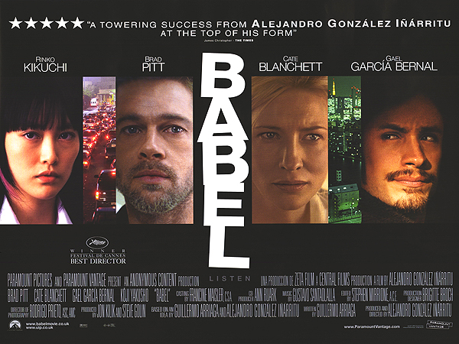

We talk about the border as a place only, instead of an idea.
I believe that the real borders are the ones that exist within us.

(Alejandro González Iñárritu, director of Babel)

1. Plot – complete the gaps

Babel (2006) is a ____________ film by the Mexican director González Iñarritu, set in Morocco, Japan, the USA and Mexico. This film really proves how globally connected - and _______________ we are. Above all, this is a narration of how difficult it is to communicate across ______________, no matter if they are physical, geographical, cultural or ________________. The film with Brad Pitt and Cate Blanchett as the American couple, Richard and Susan Jones, was nominated for seven Oscars.

psychological
multi-plot
borders
disconnected

2. Director of the film

Who directed "Babel"? Look for information about him

3. The title

Look for information about the biblical story of Babel and explain why, from your point of view…

- The film is called Babel

- Our world is like Babel biblical city

4. Cultural differences

In spite of living in an interconnected world (one of the advantages of globalization), the title and the actions in the film strongly indicates that, in our world, the lack of communication (or rather breakdown of it) is a fact. But, this lack of understanding is not just a language issue: sometimes people with a language in common, are not able to communicate in order to cultural differences.

- Point out the situations through the director wants to reflect this gap between cultures (each culture is represented by a character: Mr. and Mrs. Jones, Chieko, etc.)

- Mr. Jones and inhabitants of Morocco town.

- Chieko’s dad and Moroccan people

- Amelia and Mr. Jones

- Explain the problems caused by this lack of communication in the film

5. cultural similarities

- Considering the interlocking cross-cultural stories, what do the Moroccan, American, Mexican, and Japanese families all seem to share? Describe a scene to illustrate each.

- Describe any memorable traumatic moments in the film, when we see individuals from different cultures extend acts of kindness to someone in need or in appreciation of one's help.

6. Interpersonal differences

But, in the film, the lack of communication is also a problem between people belongs to the same culture and it causes loneliness.

- Explain why the following characters are not able to understand between them. Do they feel lonely?

- Mr. and Mrs. Jones

- Moroccan brothers

- Amelia and her nephew

- Chieko and her father

- Chieko and her peers

- Explain the problems caused by this lack of understanding

7. Different settings: one world

- Point out in the map the different locations of the film

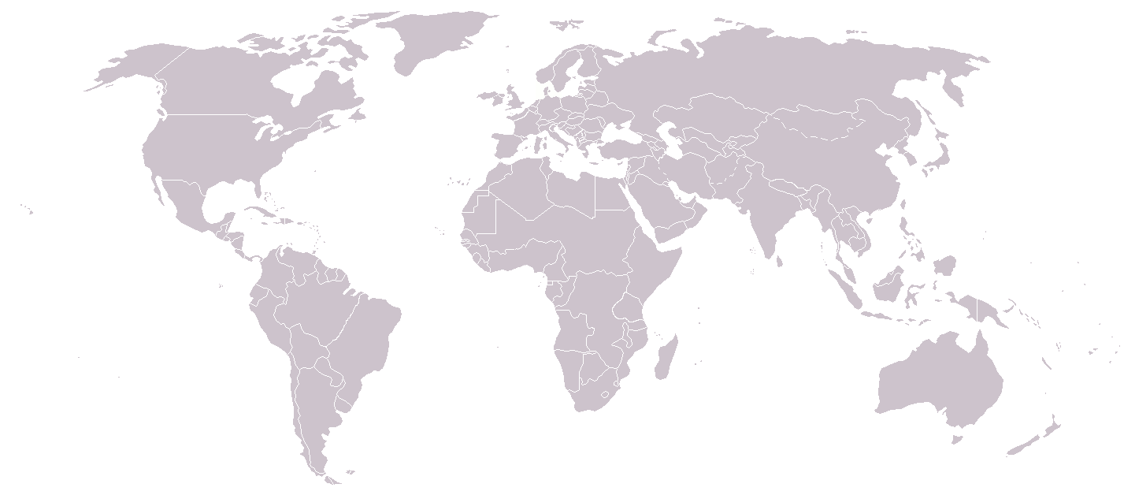

- The film shows four completely different settings. What idea does the director of the film try to reflect with these different locations?

8. Stereotypes and prejudices

Other main subject in the film is the stereotypical thinking and prejudices. Where and how does the film show the following stereotypes? Are they true, from your point of view?

- All Arabs are terrorist

- The impaired are different of the others

- USA citizens want to impose their own culture around the world

- Mexicans in EE.UU. Are illegal

